Standard and Garch

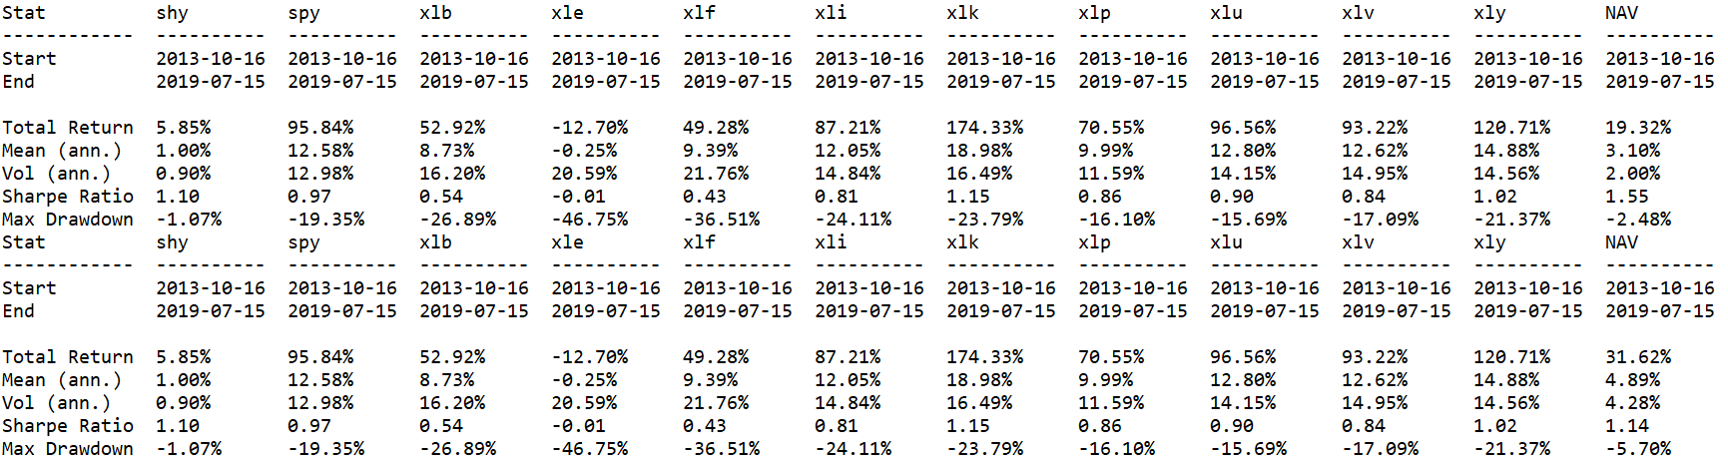

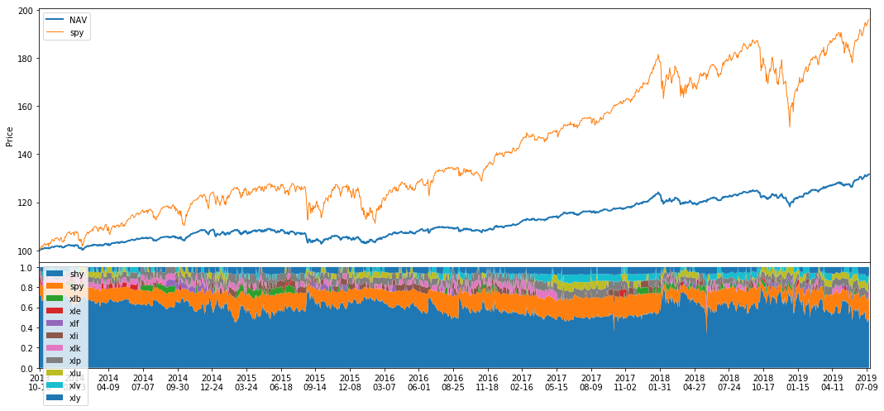

LSTM(0.05,0.55)

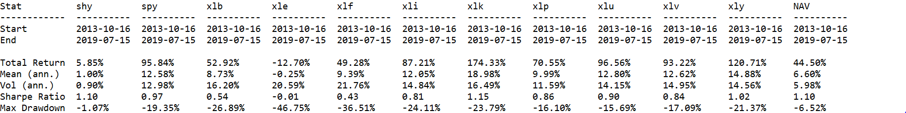

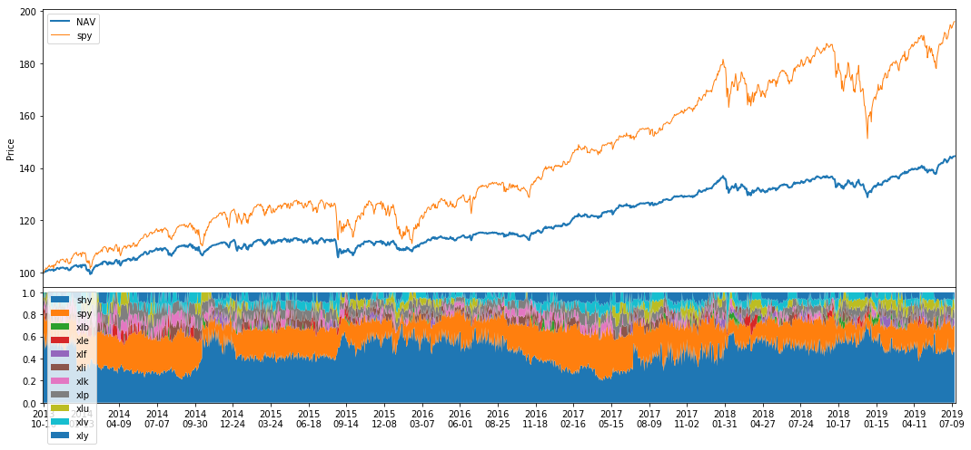

LSTM(0.05,0.55) average(5)

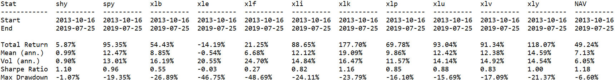

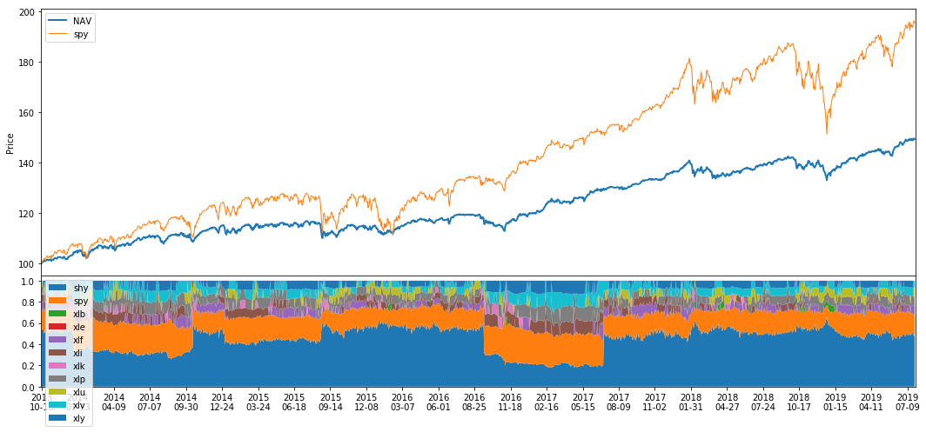

LSTM(0.05,0.55) add garch in features

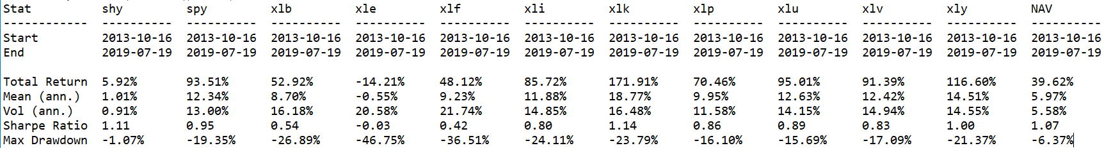

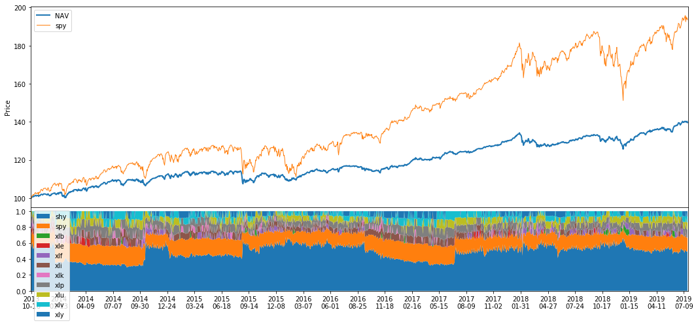

LSTM(0.05,0.55) minus variance

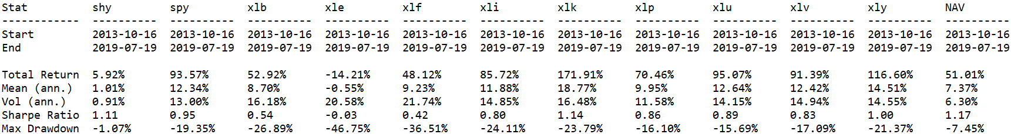

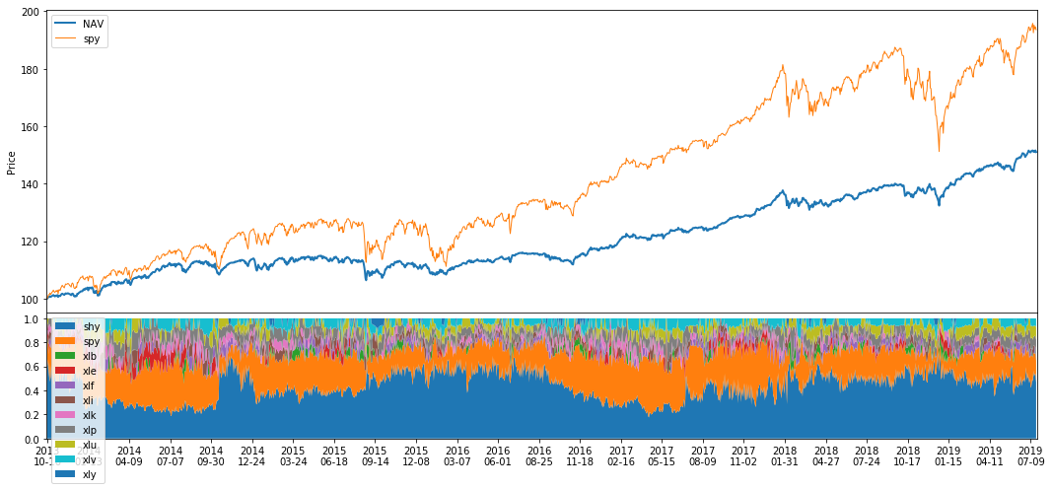

GRU(0.05,0.55) minus variance

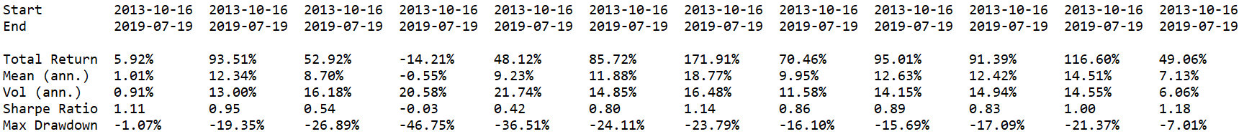

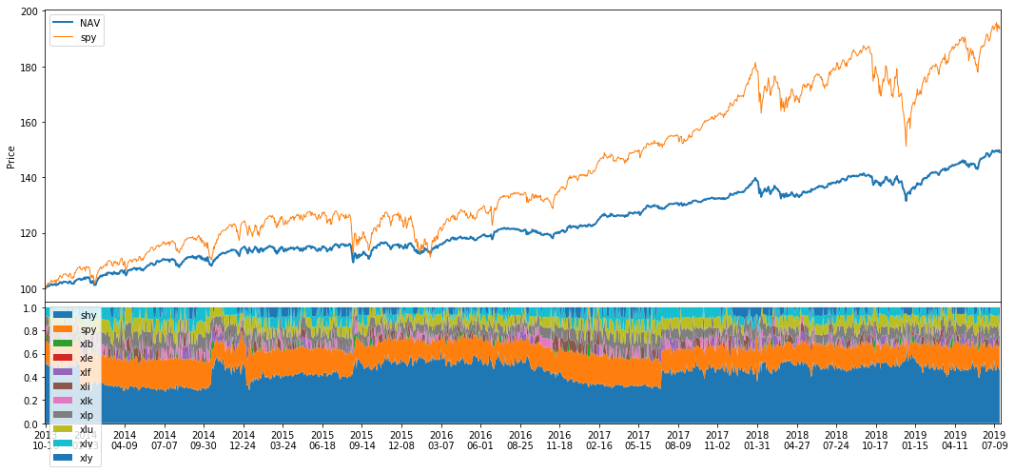

Future(0.05,0.55)

